

‘

REINFORCEMENT AND REPRESENTATION LEARNING
Lab Experiment

Name: Chitrangi Samal
Reg: 23BAI11168
Slot: B21+E14+E22
Faculty: Manoj Kumar

Lab experiment no. 1
1. Aim
To implement the Q-Learning algorithm for a simple grid environment.

2. Description
Q-Learning is a Value-Based off-policy reinforcement learning algorithm. It aims to find the best action to take based on the current state by learning a Q-table.
- The Q-Table: A lookup table where rows represent states and columns represent actions.
- Off-Policy: The algorithm learns the value of the optimal policy independently of the agent's actions.
- Update Rule: The values are updated using the Bellman equation, which considers the immediate reward plus the discounted maximum future reward of the next state.
- Exploration: Uses an epsilon-greedy strategy to balance trying new actions (exploration) and using known good actions (exploitation).

Code:
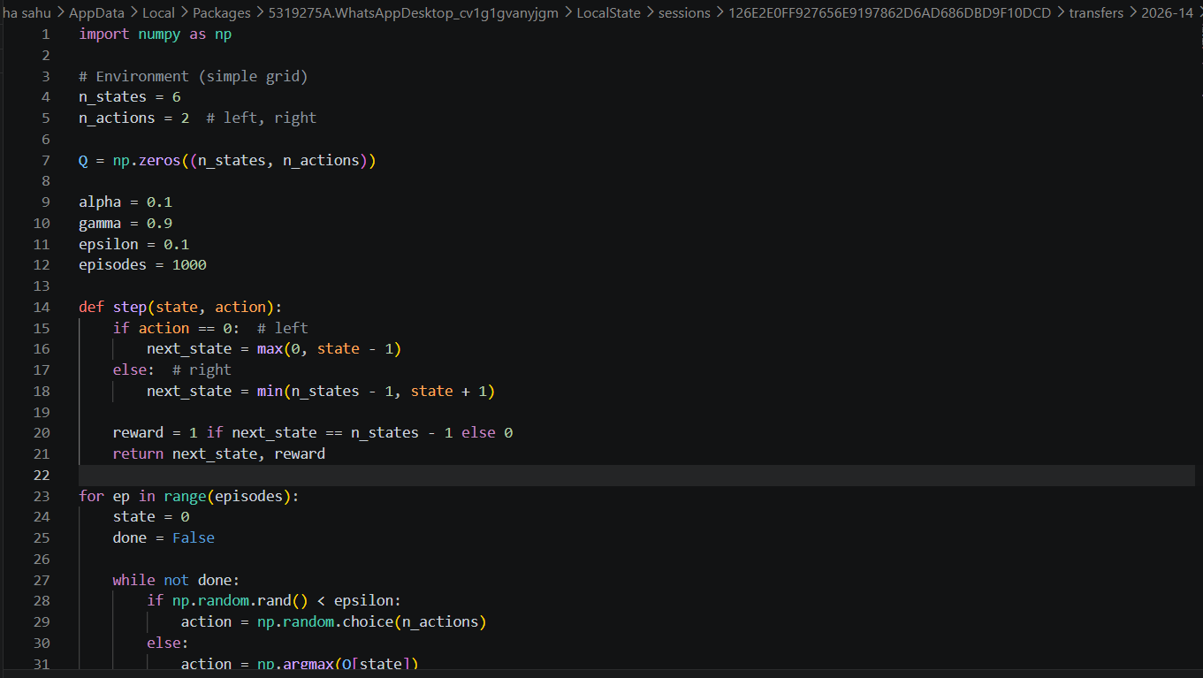

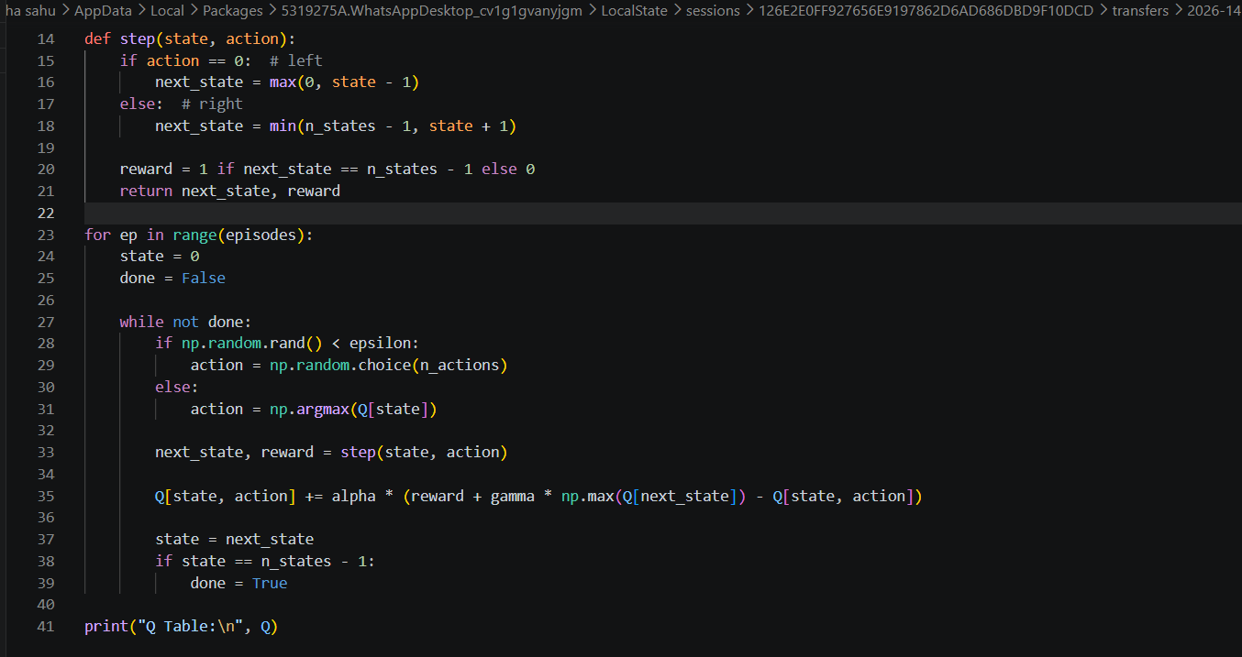
Output
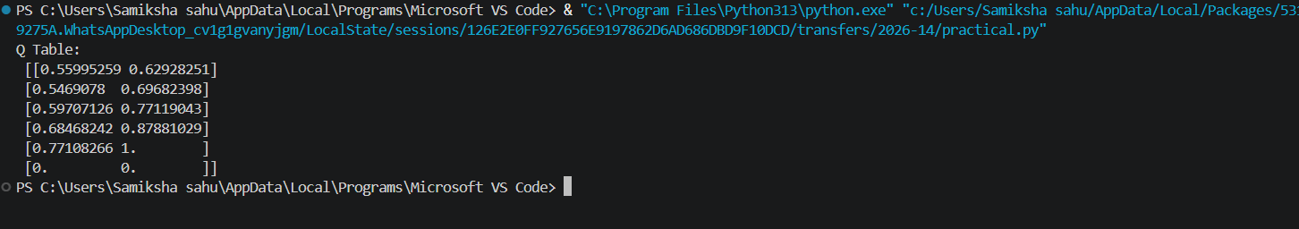

Lab experiment no. 2
1. Aim
To implement the SARSA (State-Action-Reward-State-Action) algorithm
2. Description
SARSA is an On-Policy reinforcement learning algorithm that is very similar to Q-Learning but differs in how it updates its values.
- On-Policy: Unlike Q-Learning, SARSA updates the Q-value based on the specific action actually taken by the current policy in the next state, rather than the absolute maximum possible reward.
- Dependency: The update depends on the quintuple sequence: current state ($s$), current action (a), reward (r), next state (s'), and next action (a').
- Behavior: Because it follows the current policy to update values, SARSA tends to be more "conservative" and safer during the learning process compared to Q-Learning.

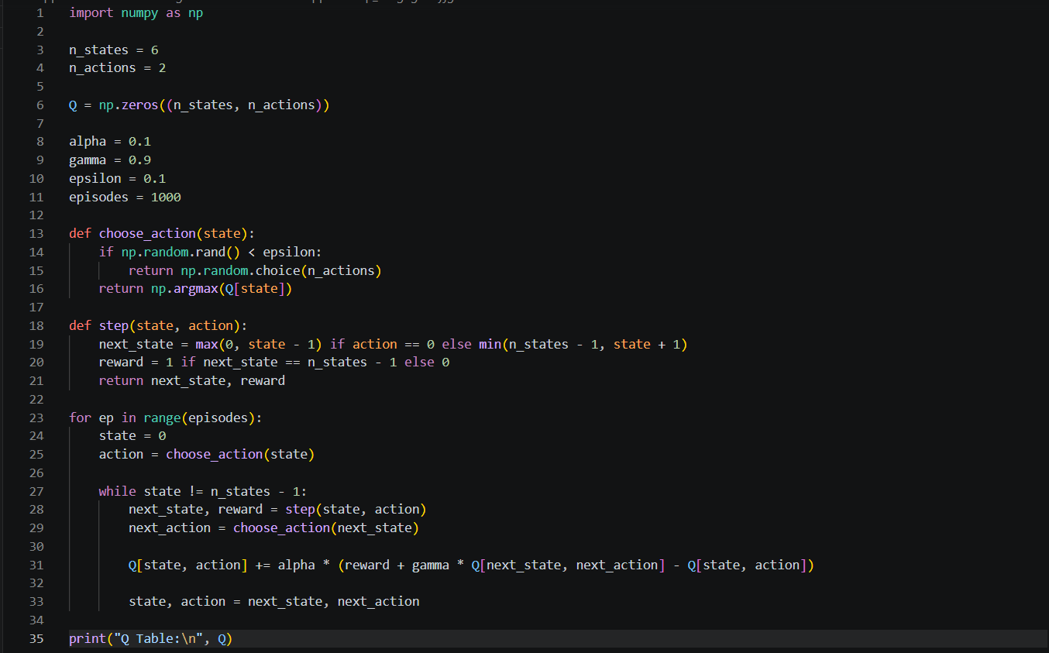
Code:-
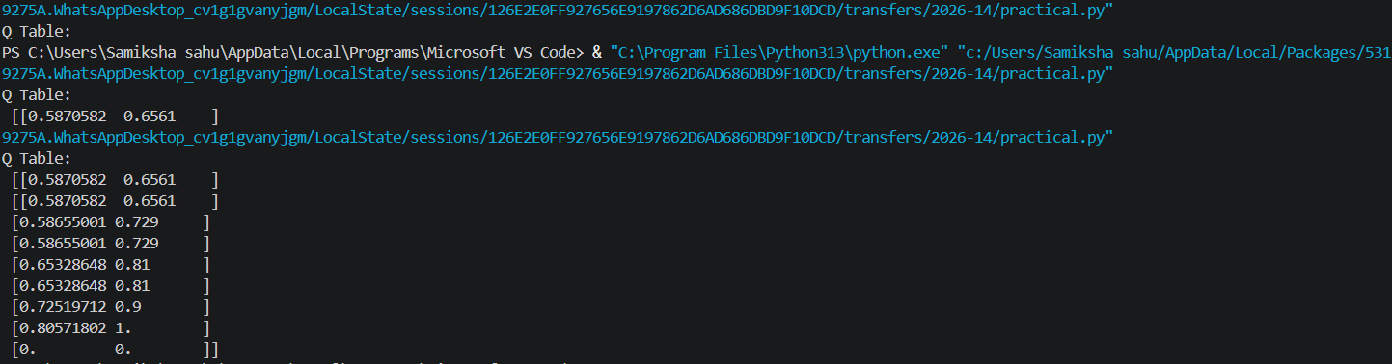
output:-

Lab experiment no.3
Aim
To implement DQN using PyTorch for a 1D grid environment

2. Description
DQN enhances traditional Q-Learning by using a Neural Network (specifically a Deep Learning model) to approximate the Q-values instead of a physical table.
- Function Approximation: This allows the agent to handle environments with a very large or continuous state space where a table would be too massive to manage.
- Architecture: In this lab, the model uses a simple neural network with a hidden layer of 32 neurons and a ReLU activation function.
- Learning Goal: The network learns to map a state input to the predicted "Q-value" for every possible action available to the agent.
- Metric: Success is typically measured using a Learning Curve, which plots the total reward earned over many training episodes.

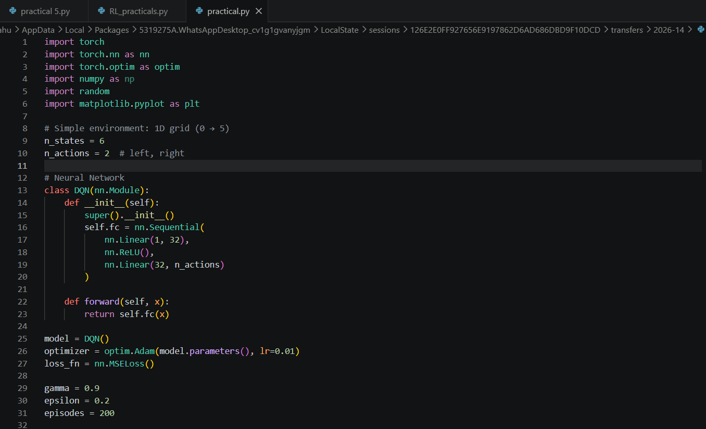
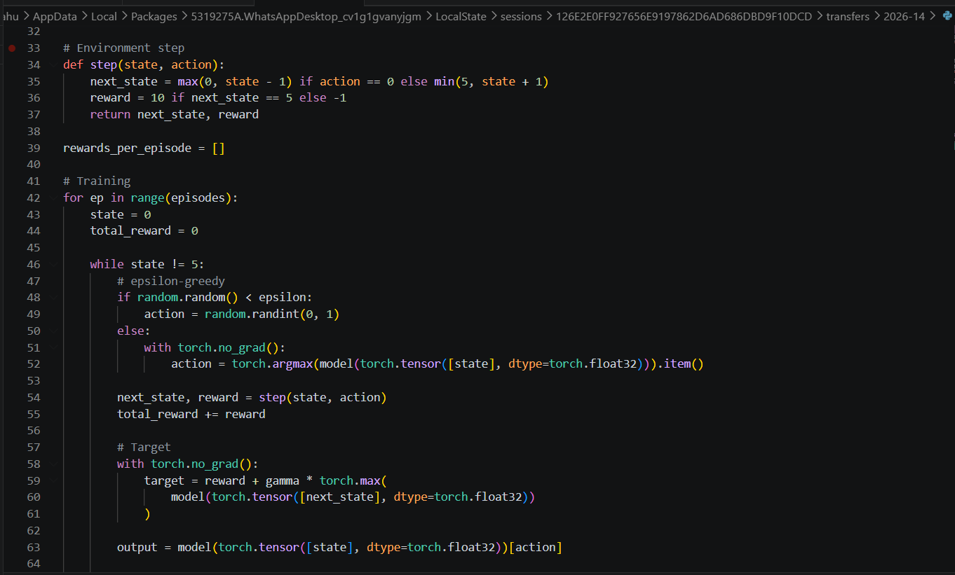
Code

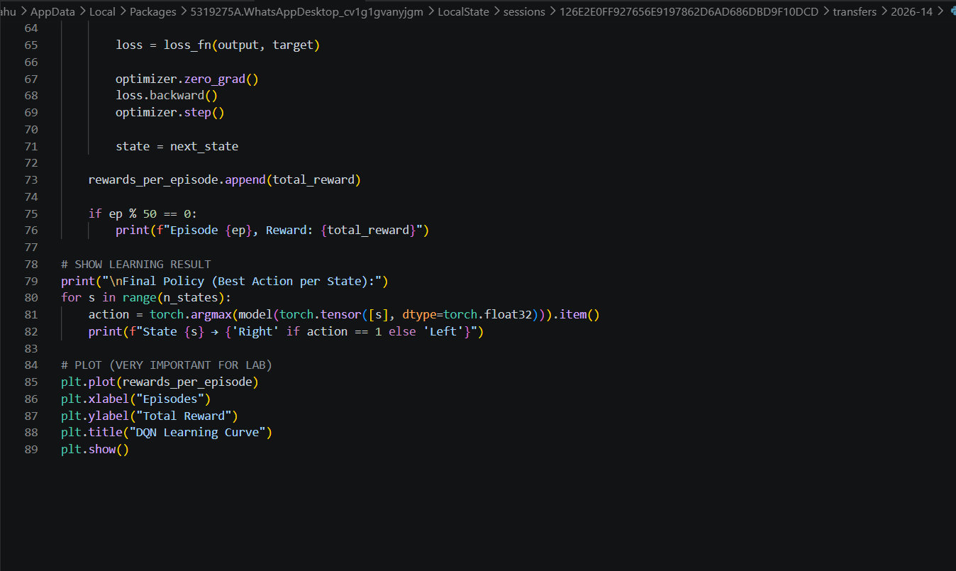

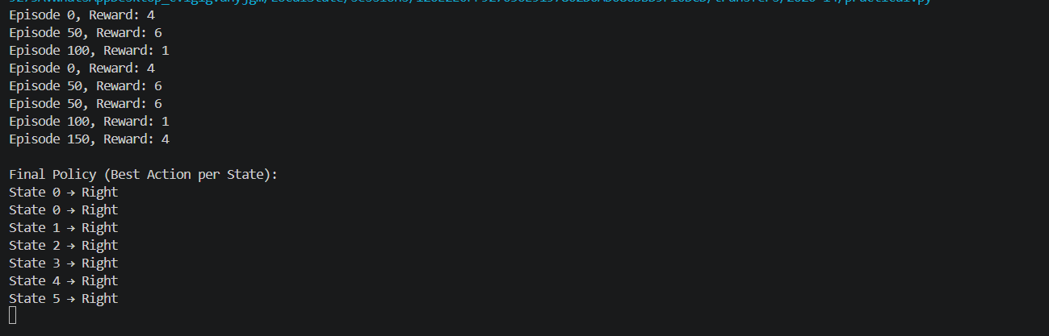
Output:-

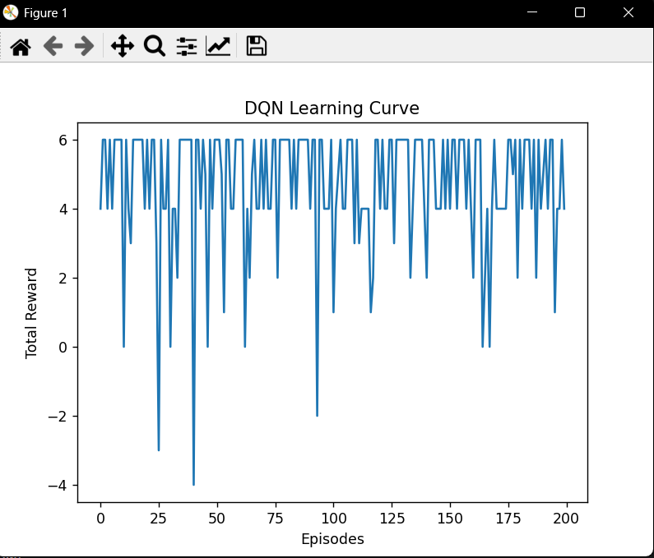

Lab experiment no. 4
Aim
To implement the Actor-Critic based DDPG algorithm.

2. Description
DDPG is an Actor-Critic algorithm designed specifically for environments with continuous action spaces.
- Hybrid Architecture: It combines the benefits of Policy-based methods (which decide actions) and Value-based methods (which evaluate actions).
- The Actor: A neural network that learns the policy (pi). It maps states directly to a specific, deterministic action.
- The Critic: A neural network that learns the value function ($Q$). It evaluates the action taken by the actor by calculating how "good" the resulting state is.
- Bounded Output: In this implementation, the Actor uses a tanh activation to ensure the actions stay within a specific range (e.g., -1.0 to 1.0)

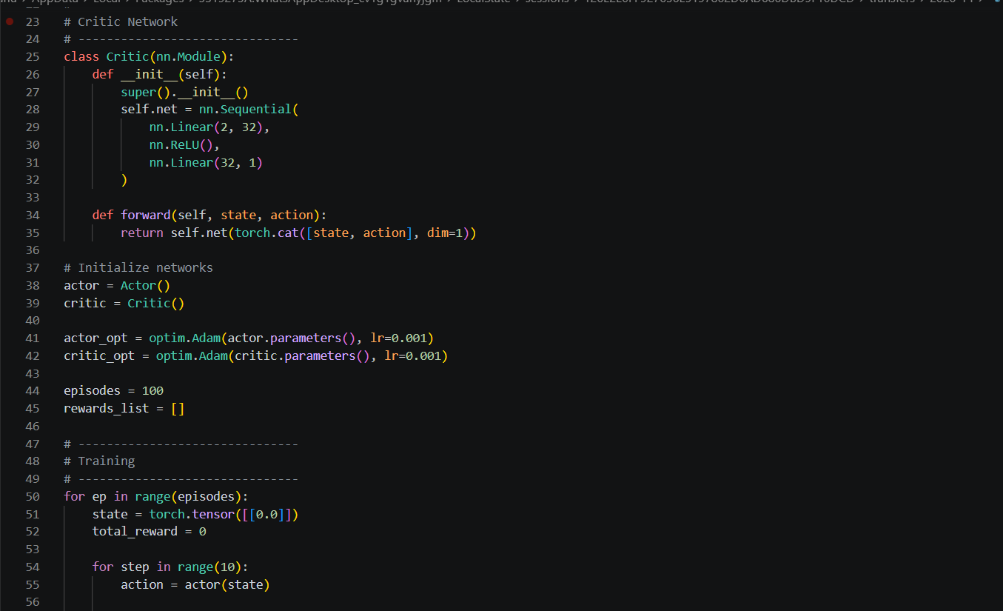
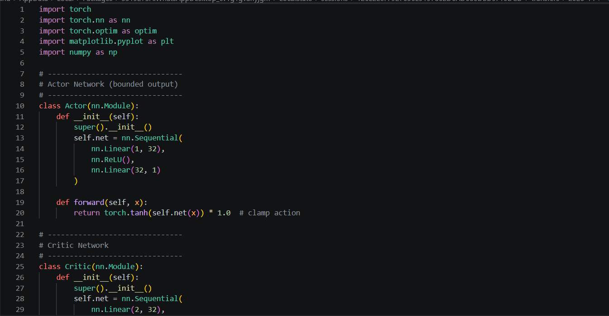
code:-

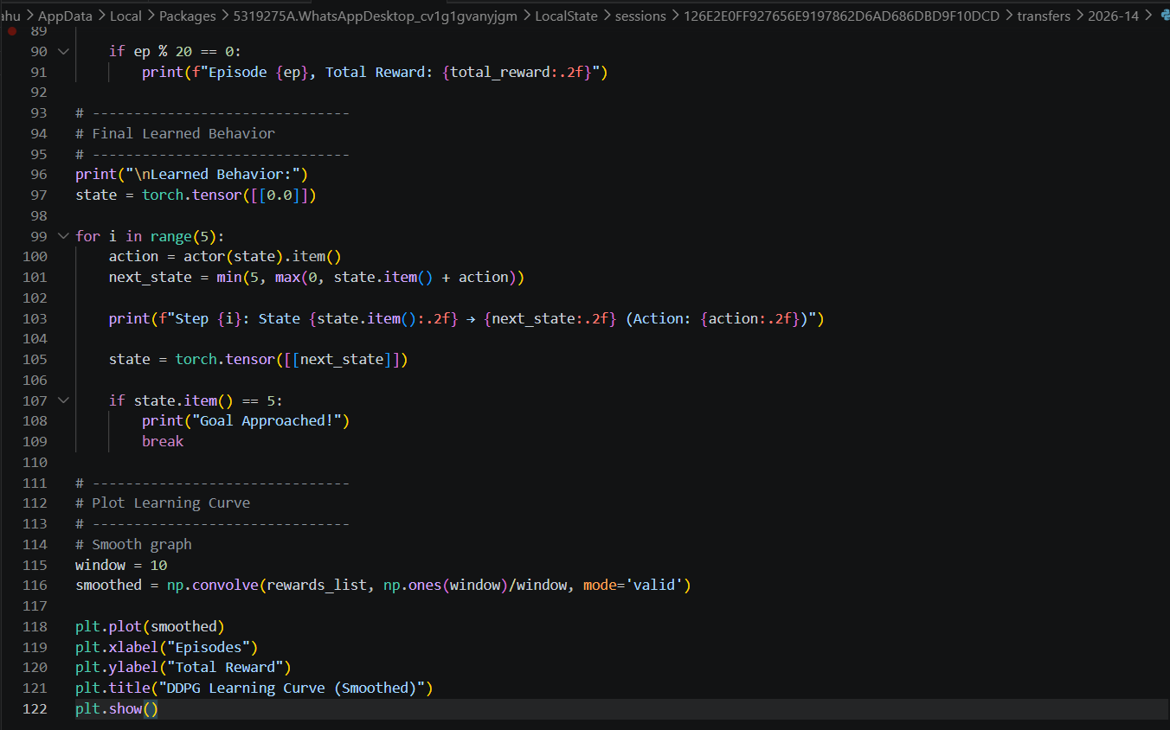
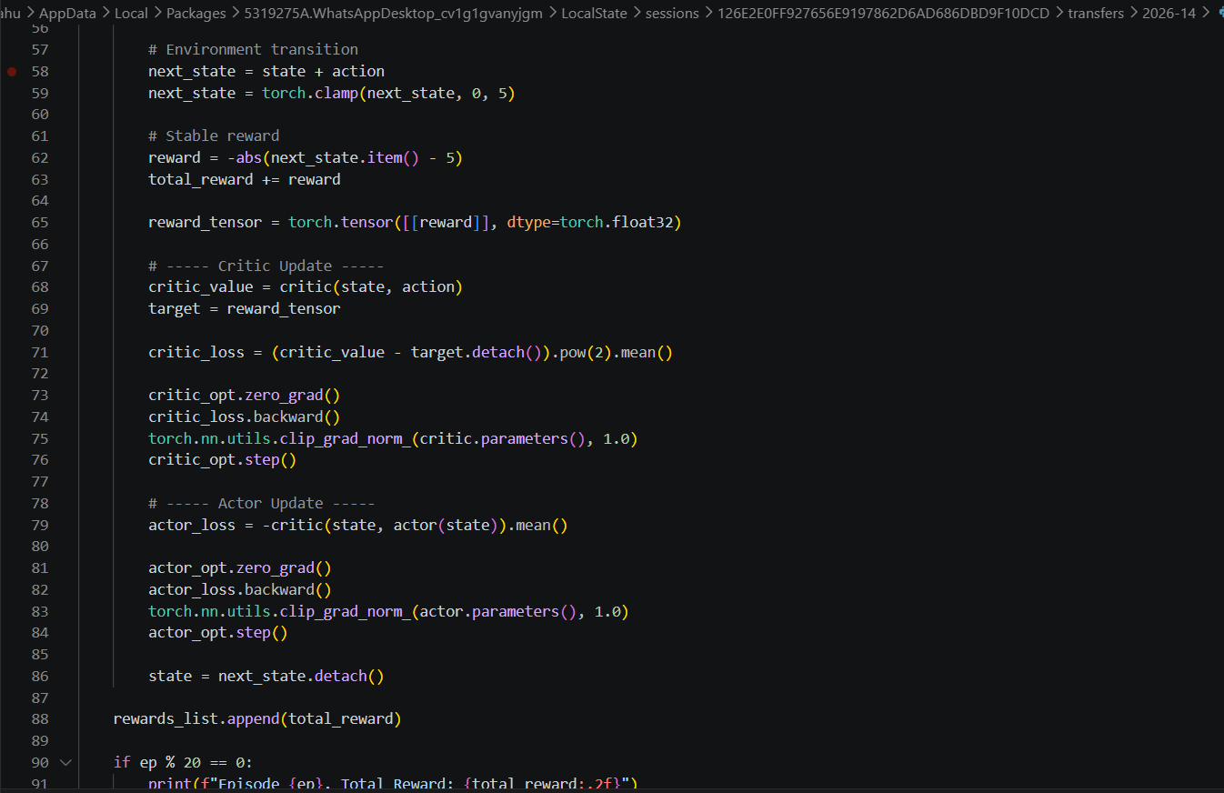
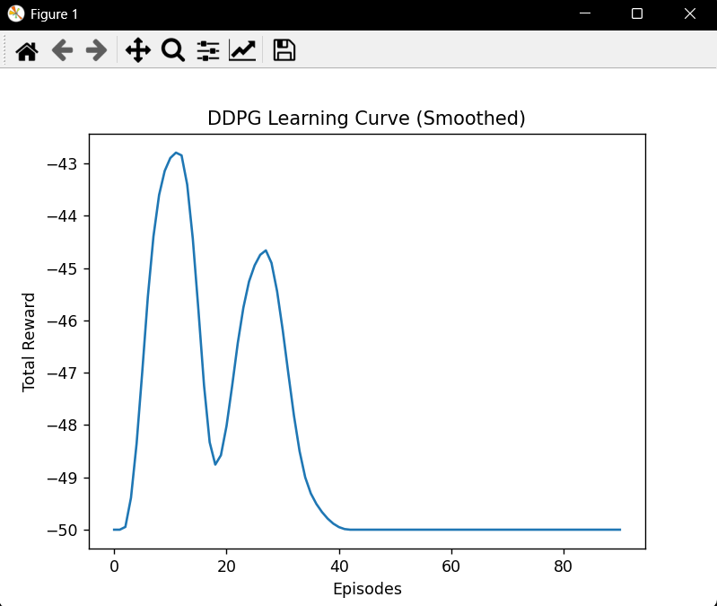
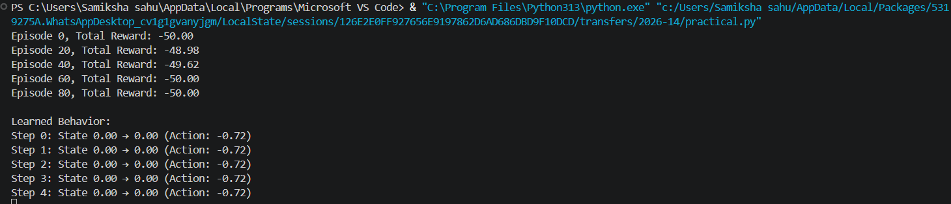
Output:-

Lab experiment no. 5
Based on the Actor-Critic Algorithm(A3C)

1. Aim
To implement and analyze the Actor-Critic reinforcement learning algorithm

2. Description
The Actor-Critic algorithm is a hybrid architecture that combines the benefits of Policy-based and Value-based methods.
- The Actor: Learns the policy pi(a|s). It decides which action to take by mapping states to a probability distribution.
- The Critic: Learns the value function V(s). It critiques the actions made by the actor by calculating how "good" the resulting state is.
- The Advantage (A): In this experiment, we use the Temporal Difference (TD) error as the advantage:


Where r is reward
gamma is the discount factor
V(s') is the value of the next state,
and V(s) is the value of the current state
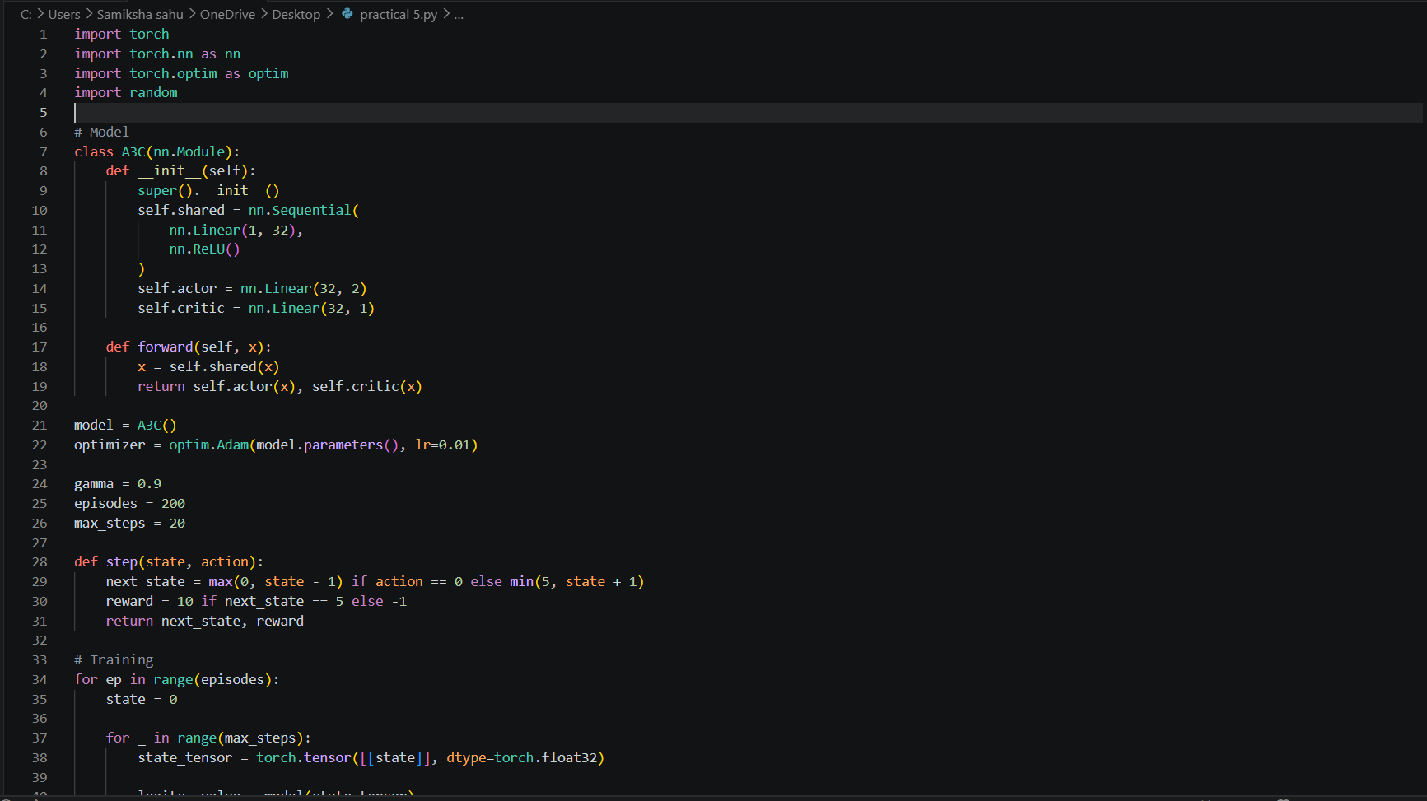
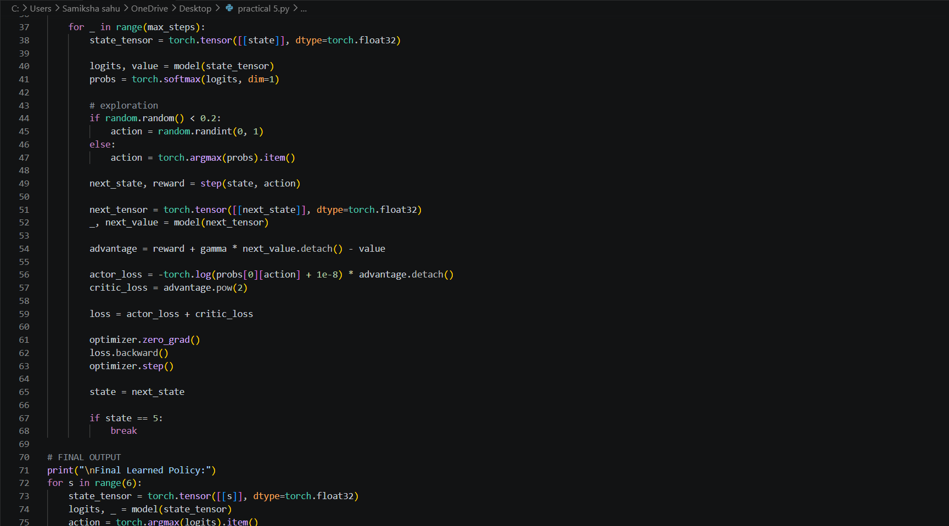
Code :-

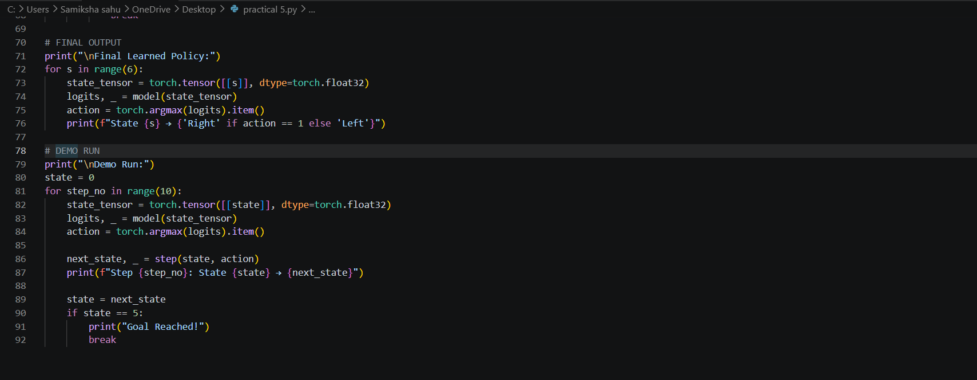

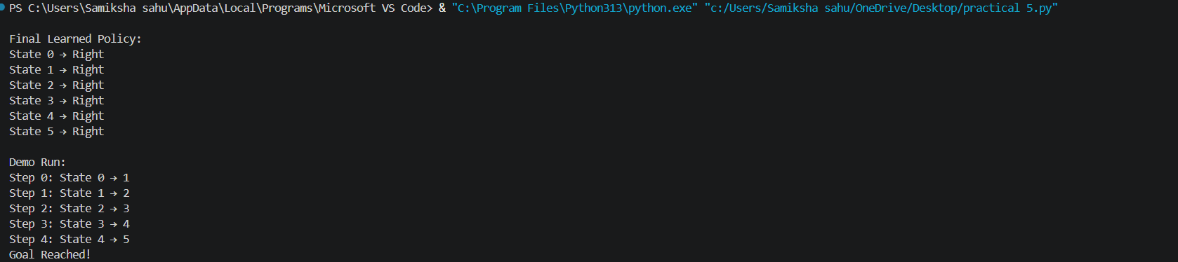
Output:-

